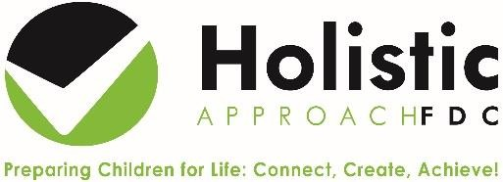
Sustainable Practice Self Audit
Educator

Date

Sustainable Practice | Y, N, N/A | Comments/Evidence/Future Goals
Service provides Open Ended Resources and recycled goods, and children are encouraged to use materials in a flexible and creative way
Second hand and preloved resources are utilised
Resources are repaired and upcycled where possible
Service correctly uses waste and recycling bins
Service uses compost systems
Service uses recycled water/water tanks
Service uses Digital Programming and Parent Communication systems, limiting printing
Services uses Digital Sign in and Enrolment Procedures and Digital filing systems, limiting printing
Sustainability linked in Philosophy
Educators role model and children are encouraged to practice energy efficiency and water saving
Children are educated about their impact on the earth and the interdependence between land, animals, plants and humans
Outdoor play and connecting with nature is embedded in the program
Sustainable projects/events are part of the program, eg Earth Hour, Plastic Free July
Children are educated about growing and making their own food
Families are encouraged to pack sustainable lunch boxes

